**🌐 Web Development MCQs (Snippet Based)**

**1.**

**What will be displayed in the browser?**

**<p>Hello <span style="display:none;">World</span></p>**

**a) Hello World  
b) Hello  
c) World  
d) Nothing**

**2.**

**Which HTML element is correct for linking an external stylesheet?**

**? rel="stylesheet" href="style.css">**

**a) <link>  
b) <style>  
c) <script>  
d) <meta>**

**3.**

**What is the output?**

**<h1>Title</h1>**

**<h2>Title</h2>**

**a) Both same size text  
b) h1 larger than h2  
c) h2 larger than h1  
d) Error**

**4.**

**What is the background color of the paragraph?**

**<p style="background-color: rgba(255,0,0,0.5);">Hello</p>**

**a) Red transparent  
b) Solid red  
c) White  
d) No color**

**5.**

**What will happen?**

**<a href="https://example.com" target="_blank">Click</a>**

**a) Opens in same tab  
b) Opens in new tab  
c) Shows error  
d) Opens in popup**

**6.**

**Which tag makes text italic?**

**? This is italic ?**

**a) <i> </i>  
b) <em> </em>  
c) <italics> </italics>  
d) Both a & b**

**7.**

**What is the correct way to add inline CSS?**

**<p ?="color:red;">Hello</p>**

**a) css  
b) style  
c) font  
d) inline**

**8.**

**What will this code display?**

**<img src="wrong.jpg" alt="Image not found">**

**a) Nothing  
b) Broken image icon  
c) Image not found  
d) Error**

**9.**

**Which selector selects all <p> inside <div>?**

**? { color: blue; }**

**a) div + p  
b) div > p  
c) div p  
d) p div**

**10.**

**What does this CSS rule do?**

**p:first-child { color: green; }**

**a) All p tags green  
b) First p inside parent green  
c) First line green  
d) Error**

**11.**

**What is the margin of the box?**

**div { margin: 10px 20px; }**

**a) Top/Bottom 20, Left/Right 10  
b) Top/Bottom 10, Left/Right 20  
c) All 10  
d) All 20**

**12.**

**What will be displayed?**

**<p>&lt;Hello&gt;</p>**

**a) <Hello>  
b) Hello  
c) Error  
d) Nothing**

**13.**

**Which property makes text bold in CSS?  
a) font-weight  
b) text-style  
c) bold  
d) font-bold**

**14.**

**What does this do?**

**div { position: absolute; top: 10px; left: 20px; }**

**a) Relative positioning  
b) Fixed in place  
c) Moves div 10px down, 20px right  
d) Stays at default**

**15.**

**What is the grid column span of the item?**

**.item { grid-column: 1 / span 2; }**

**a) 1 column  
b) 2 columns  
c) 3 columns  
d) Error**

**16.**

**What happens here?**

**<input type="checkbox" checked>**

**a) Box unchecked  
b) Box checked  
c) Error  
d) No display**

**17.**

**Which CSS rule applies hover effect?  
a) a:hover  
b) a:focus  
c) a:active  
d) a:visited**

**18.**

**What will flexbox do?**

**.container { display: flex; justify-content: space-between; }**

**a) All items overlap  
b) Items spread evenly with space between  
c) Items aligned left  
d) Error**

**19.**

**Which CSS unit is relative to parent font size?  
a) px  
b) em  
c) %  
d) vh**

**20.**

**What is the output?**

**<ul>**

**<li>One</li>**

**<li>Two</li>**

**</ul>**

**a) One Two  
b) - One - Two  
c) 1. One 2. Two  
d) Error**

**21.**

**Which tag is semantic?  
a) <div>  
b) <section>  
c) <span>  
d) <b>**

**22.**

**What happens here?**

**<form>**

**<input type="text" value="Hello">**

**</form>**

**a) Empty box  
b) Box with Hello  
c) Error  
d) Placeholder Hello**

**23.**

**Which CSS makes animation?  
a) @animation  
b) @keyframes  
c) transform  
d) transition**

**24.**

**What does this do?**

**div { transform: rotate(45deg); }**

**a) Rotates text  
b) Rotates div box 45 degrees  
c) No effect  
d) Error**

**25.**

**Which framework is CSS based?  
a) Django  
b) Flask  
c) Bootstrap  
d) React**

**26.**

**Which tag creates a table row?  
a) <tr>  
b) <td>  
c) <th>  
d) <table-row>**

**27.**

**What does z-index do?  
a) Moves item left-right  
b) Moves item front-back  
c) Rotates item  
d) No effect**

**28.**

**Which input type hides characters as you type?  
a) text  
b) password  
c) hidden  
d) secure**

**29.**

**What does this snippet show?**

**<a href="#section2">Go Down</a>**

**a) Opens another page  
b) Scrolls to section2  
c) Error  
d) Does nothing**

**30.**

**Which CSS property sets spacing between letters?  
a) word-spacing  
b) letter-spacing  
c) spacing  
d) text-indent**

**1.Problem Statement:**  
Write a Java program to print a **chess board pattern** of size N x N.

* The board should alternate between B (Black) and W (White).
* The top-left corner should always start with B.
* Input: An integer N.
* Output: The N x N grid pattern.

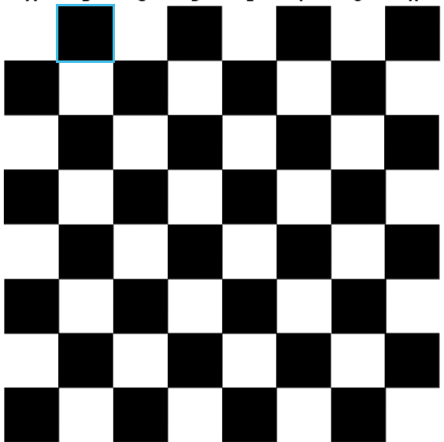

2. **Question 2: Web Development (HTML + CSS)**

**Problem Statement:**  
Create a **simple HTML page** with the following requirements:

1. The page should display a **navigation bar** with 3 links: **Home, About, Contact**.
2. The navigation bar should have a background color of **black** and text color of **white**.
3. When a user hovers over a link, the text color should change to **yellow**.
4. Below the navigation bar, display a heading: **"Welcome to My Website"** in the center of the page.

**Expected Output (when rendered in browser):**

* A black navigation bar with 3 white links aligned horizontally.
* On hover, links turn yellow.
* Heading displayed below in the center.